Bill of materials:
- Black Self-Adhesive Hook and Loop Tape [4 cm Width] for the front face of the belt.
- White Self-Adhesive Hook and Loop Tape [2 cm Width] for the windlass strap.
- Polyester Cotton Webbing Strap [4 cm Width] for the back face of the belt.
- Nylon Heavy Webbing Strap [2.5 cm Width] for the internal belt.
- Double Cap Rivet
- Polyester Thread [0.75 mm Thickness]
- Super Glue
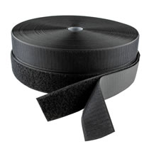 | 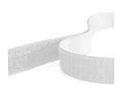 | 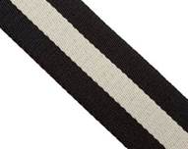
Black Self-Adhesive Hook and Loop Tape | White Self-Adhesive Hook and Loop Tape | Polyester Cotton Webbing Strap
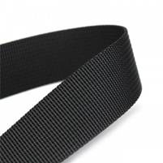 | 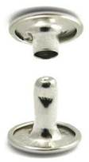 | 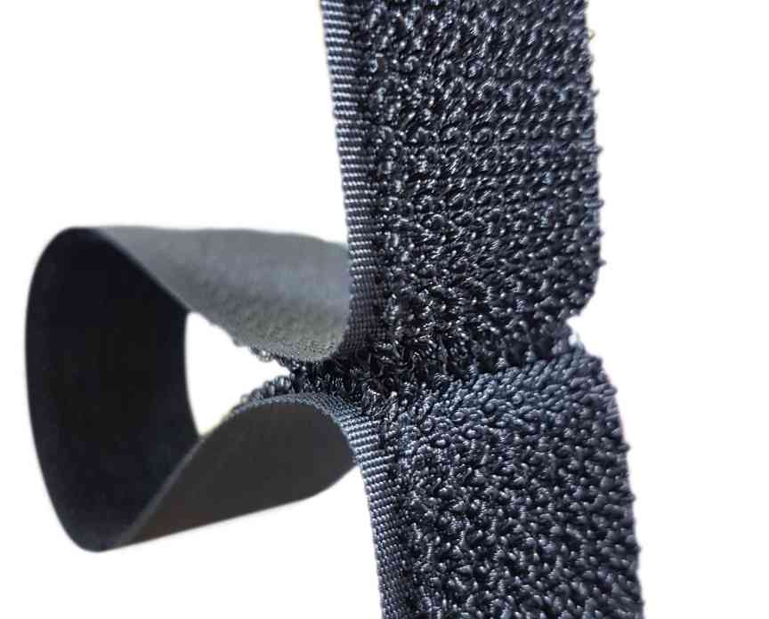
Nylon Heavy Webbing Strap | Double Cap Rivet | Omni Tape

* Note: You can use one piece of Omni tape instead of using separate parts of hook and loop.

Work Steps:
- Cut all the straps to the required length.
- Black Self-Adhesive Hook and Loop Tape (Hook: 3 pieces 6 cm each & one piece 15 cm length, Loop: one piece 6 cm, two pieces 12.5 cm, one piece 19 cm)
- White Self-Adhesive Hook and Loop Tape (Hook:20 cm, Loop: 20 cm) one piece for each.
- Polyester Cotton Webbing Strap (one piece 97 cm).
- Nylon Heavy Webbing Strap (one piece 97 cm).
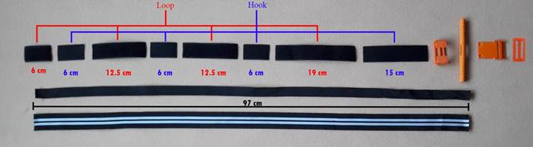
2. In the front face of the belt, sew the straps together sequentially [6 cm Loop, 6cm Hook, 12.5 cm Loop, 6cm Hook, 12.5 cm Loop, 6cm Hook, 19 cm Loop, 15 cm Hook].Taking into account the repetition of sewing more than once so that the tip of each piece above the tip of the next piece to facilitate the tensile process.
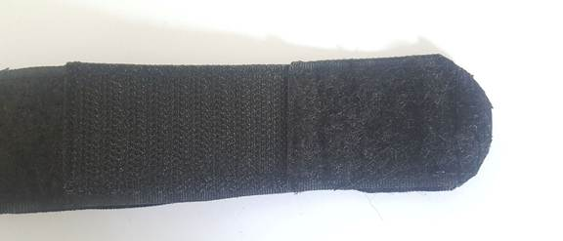

3. Sew the front face of the belt to the back face from one side and left the other side free to insert the internal belt.
4. Insert the internal belt between the front and back face. Sew the tip of the belt with the other belts and then repeat the sewing more than once on zig-zag shape till 5 cm of the tip.
5. Sew the front face of the belt to the back face from the other side, taking into account to keep the internal belt far from the sewing area to keep it free to move.
6. Drill two holes on the top sides of 15 cm hook piece.
7. use double cap rivet to fasten the belt with supporting slice together through the two holes.
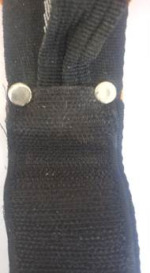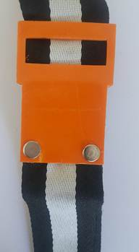
8. Insert the belt through windlass clamp slot until it reaches the supporting slice, taking into account to keep the wide-open area of the windlass clamp toward the tip of the belt.
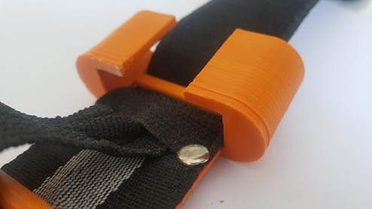
9. Insert the internal belt through windlass rod slot. After that insert the belts through the supporting slice.
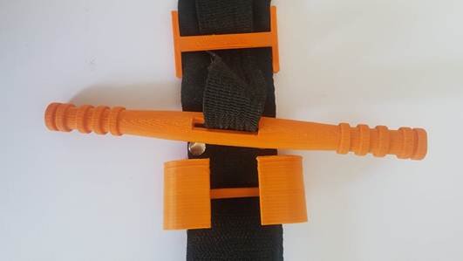
10. Pull the windlass rod toward windlass clamp to maintain extra length of internal belt in the windlass rod area that allows to make tension.
11. Insert the free end of the belt through the toothless slot of the buckle, then bend it upward and sew the belt on itself. Taking into account the repetition of sewing more than once.
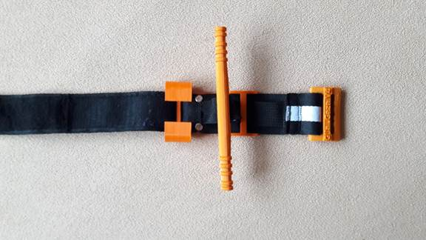

12. Remove any extra threads.

13. Cut the end of the belt in an elliptical shape.
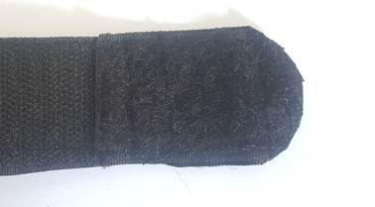
14. Press the tip of the belt to make it easy to insert through the buckle.
15. Sew white Self-Adhesive Hook to the loop from the center to make windlass strap.
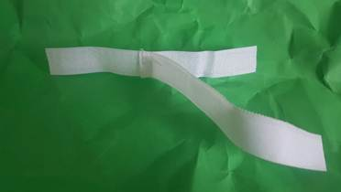
16. Use super glue to fasten windlass strap on windlass clamp.
